**GSE Algebra I Syllabus 2017-2018**

**Instructors:**

Crystal Mayben [CMayben@paulding.k12.ga.us](mailto:CMayben@paulding.k12.ga.us)

**GSE Algebra I Course Description:**

**Algebra I** is the first course in a sequence of three required high school courses designed to ensure career and college readiness. The course represents a discrete study of algebra with correlated statistics applications. The standards in the three-course high school sequence specify the mathematics that all students should study in order to be college and career ready. Additional mathematics content is provided in fourth credit courses and advanced courses including pre-calculus, calculus, advanced statistics, discrete mathematics, and mathematics of finance courses. High school course content standards are listed by conceptual categories including Number and Quantity, Algebra, Functions, Geometry, and Statistics and Probability. Conceptual categories portray a coherent view of high school mathematics content; a student’s work with functions, for example, crosses a number of traditional course boundaries, potentially up through and including calculus. Standards for Mathematical Practice provide the foundation for instruction and assessment.

**Grading Policy:**

|  |
| --- |
| **Block** |
| **Summative: 57%** tests, presentations, projects, portfolios, large tasks, etc. |
| **Formative: 23%** quizzes, homework, classwork, warm-ups, tasks, etc. |
| **Georgia Milestones: 20%** |

**Materials Needed: Recommended**

**Infinite Campus Mobile Portal App:**

Access your child’s schedule, grades, and attendance data using this app!

District Code: JFLNRG

[](http://www.google.com/url?sa=i&rct=j&q=infinite+campus+mobile+portal&source=images&cd=&cad=rja&uact=8&docid=AGyWJHtR5uUK_M&tbnid=OB0EK6LYS-3UAM:&ved=0CAUQjRw&url=https://play.google.com/store/apps/details?id%3Dcom.infinitecampus.mobilePortal&ei=bHbaU8XqL5DIsASRwIDIBg&bvm=bv.72185853,d.cWc&psig=AFQjCNF0oI9hmGxX5rL58_CLuH_kQMVLXA&ust=1406912491690044)

Pencils

3-Ring Binder (1”-1.5”)

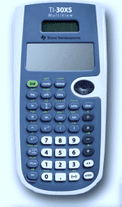[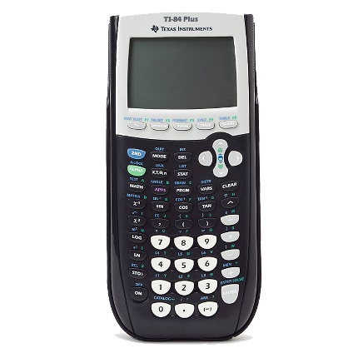](http://www.google.com/url?sa=i&rct=j&q=&esrc=s&frm=1&source=images&cd=&cad=rja&uact=8&ved=0CAcQjRxqFQoTCJCp6qv4gMcCFZcPkgodSnkKRw&url=http://www.amazon.com/Texas-Instruments-TI-84-Graphing-Calculator/dp/B0001EMM0Q&ei=aRe5VdDQEpefyATK8qm4BA&bvm=bv.99028883,d.aWw&psig=AFQjCNGrRY4QPn15G3AXpXk2V2PB8lTK-A&ust=1438279909424840)Graph Paper

Notebook Paper

Calculator

TI-30XS TI-84+

**Class Wish List:**

These items are used almost daily for all students. Donations are greatly appreciated!

**Dry Erase Markers Markers Copy Paper Tissues**

**Hand Sanitizer Pencils Paper Towels Erasers**

**Colored Pencils Crayons Colored Paper Graph Paper**

**Homework:**

To master the mathematics standards, practice is essential. Therefore, homework will be assigned daily. Homework may be graded as an appropriate measure of learning. If homework is collected, ***no late homework assignments*** will be accepted.

**Classwork:**

Classwork is designed to be completed in class and is due the day it is assigned. If a student is in class and chooses not to complete an assignment, he or she will not be given an opportunity to make that assignment up. ***No late classwork assignments*** will be accepted.

**Make-up Work:**

If a student is absent from class, he/she is responsible for any missed assignments. Missed tests or quizzes must be made up within ***three days*** of the student’s return to school. The student ***must come in before or after school*** to make up the missed assessment. Class time ***will not*** be given for make-up assessments.

**Recovery Policy:**

Students will not have the opportunity to recover quizzes. Recovery will be allowed for specific tests. Before the student retakes the test, they are required to reflect on their previous score, make corrections on the original test, and attend a least one tutoring session to improve understanding of the concepts. After completing these requirements, students may take the recovery test before or after school. The highest replacement test grade that a student can earn is an 80.

**Discipline:**

Consequences for breaking classroom rules:

1st time – verbal warning

2nd time – parent contact and/or classroom discipline (seat changed, teacher detention, etc.)

3rd time – office referral

Additional violations will result in office referrals.

**PLEASE COMPLETE & RETURN BOTTOM SECTION**

I have received a copy of the Algebra 1 Syllabus. I have read and understand the policies and procedures stated.

Student Signature: __________________________________ Date: _________________________

Parent/Guardian Signature: ________________________________